**Q1 A. Create a folder named "RPractical "in your home directory /c:drive. 2. set the working directory to this folder 3.Create ordinal categorical vector with values 'evening ', 'morning','afternoon','midday',midnight','evening'. 4. convert it to factor with ordered level. 5.display the above created factor.**

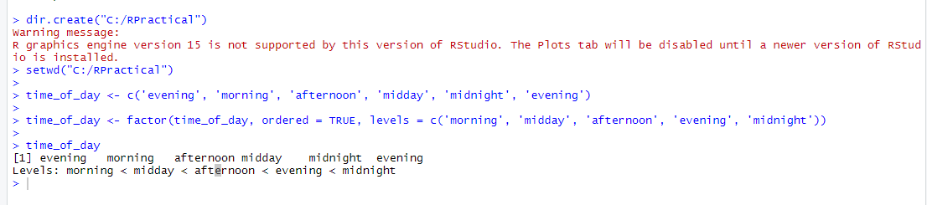

**Q2) A) Perform ETL process in pentaho with excel as input and excel as output after applying any 3 transformation onsales data in pentaho**

**A)Adding Sequence**

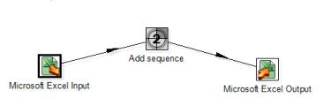

**2)Adding calculator**

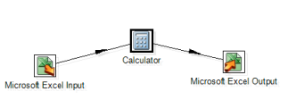

**3 )concate**

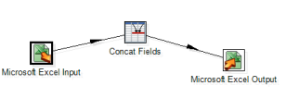

**Q2) B) 2 Create table sales(sid,ssname,salesregion) with 3 partition using list partition based on region**

1. **describle the structure of the table and display the partition of table . b)insert minimum 6 records and display the content from each partition. c)Update any one records from each partition and display the content from eachpartition**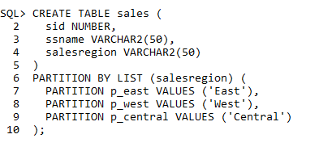

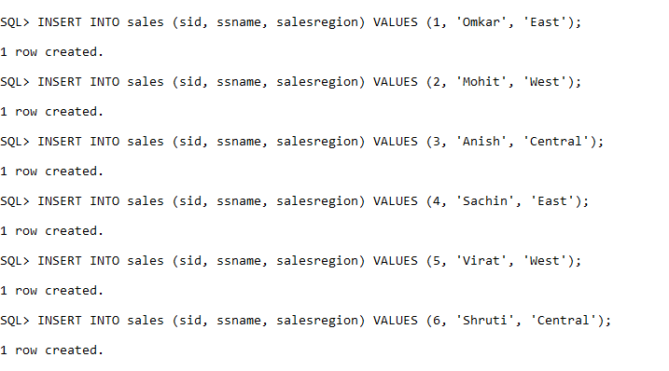

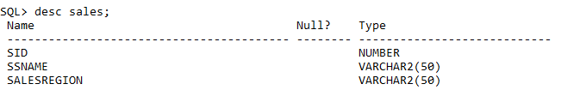

B)

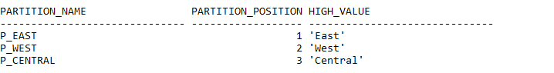

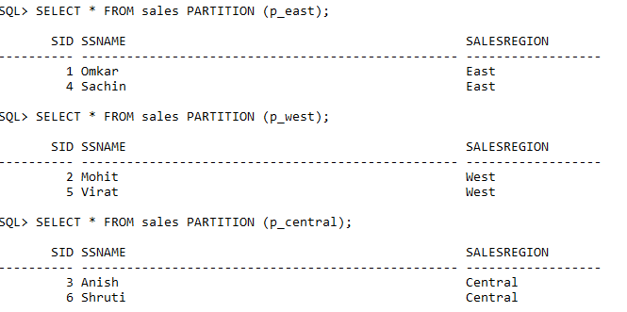

C)

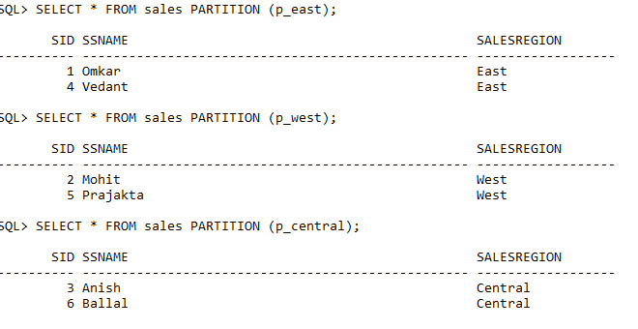**Q3 A Create abstract datatype of Book_type containing Bookno , title , Author , pub_date , price .**

**Create a table Books of Book_type.**

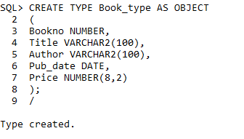

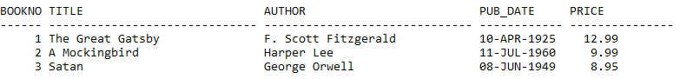

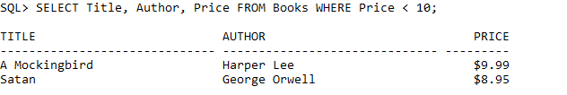

**B** Show the usage of the LEAD and Lag Analytical Function on following table in oracle.

